**ACTIVITY: BELT FEEDER MAINTENANCE**

1. **Purpose:** - To describe Safe and quality maintenance procedure of Belt Feeders and weigh feeders for optimum output
2. **Scope:** - All weigh feeders of CHP, belt feeders of jetty unloaders and coal feeders.
3. **References.**: - Belt feeder maintenance manual and material handling maintenance manual.
4. **Responsibility**: - Engineer- in- charge & Maintenance fitter on the job.
5. **SAFETY PRECAUTIONS:**

* Ensure all Process, Electrical & Mechanical isolation prior to starting work on equipment. Follow documented isolation procedure as per Vedanta approved isolation standards.
* Seek Proper work permit if applicable.
* Job to be carried out by Competent Person.
* Safety briefing / Toolbox talk to be carried out and to be documented.
* Ensure Certified tools and tackles to be used for carrying out ant activity.
* Do not use Inhouse fabricated and tempered tools.
* Follow one man one lock system and use of LOTO box.
* Wear safety approved PPE (Personal Protective Equipment)
* Ensure that workplace is clean and safe.
* Operate pull cord switch / LCS to Off position prior to work as an additional safety measure.
* Ensure all the planned jobs have been completed and release mechanical isolations if applied.
* All unwanted material from the area to be removed before releasing the equipment electrical isolation.
* Follow proper documented procedure for releasing the electrical isolations as per Vedanta approved isolation standards.
* Ensure all the job is completed as planned and all safety guards have been placed and secured properly as per guidelines before releasing the equipment for operation

6.0 PPE to be used :

* Helmet,
* Safety shoes.
* Dust mask.
* Hand gloves.
* Safety goggles.
* Reflector jacket.
* Job specific PPEs face Shield, Full body Harness, lifeline, fall back arrestor, CO detector etc.

**7.0 Basic Components.**

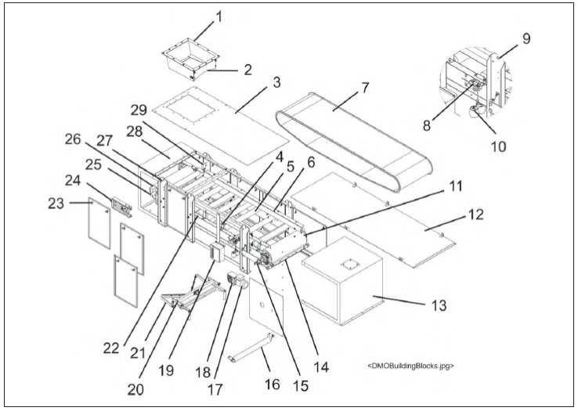

1 Infeed

2 Shear Gate

3 Top Cover

4 Proximity Sensor

5 Carrier Idler

6 Skirt board

7 Belt (1" Flange shown)

8 Compact Weigh Module Assembly

9 Lifting Point

10 Test Weights

11 Head Pulley and Shaft Assembly

12 Bottom Cover

13 Discharge End Cover

14 Head Pulley Scraper Assembly

15 Bearing

16 Return Idler Assembly

17 Motor

18 Gear Reducer

19 Local Control Station

20 Belt Tensioner and Tracking Assembly

21 Plow Scraper Assembly

22 Stringer

23 T-Handle

24 Take-Up Screw Assembly

25 Zero Speed Switch Kit

26 Tail Pulley and Shaft Assembly

27 Feeder Leg (with lifting point)

28 Infeed End Cover

29 Belt Tracking Switch Kit

**8.0 Activities**

* Activity No 1 : Conveyor belt changing.

Activity No 2 : Belt Tensioning and Tracking.

* Activity No 3 : Changing of Gear Box (Weigh Feeder)
* Activity No 4 : Changing of Motor (Weigh Feeder)
* Activity No 5 : Changing of Gear Box (Belt Feeder)
* Activity No 6 : Changing of Motor (Belt Feeder)
* Activity No.7 : Carrying roller/bracket changing.
* Activity No. 8 : Return roller/bracket changing.
* Activity No. 9 : Replacement of drive drum.
* Activity No.10 : Replacement of tail drum.
* Activity No. 11 : Replacement of snub Drum.
* Activity No. 12 : Replacement of screw take up.
* Activity No. 13 : Preventive Maintenance.

9.0 Aspect- Impact.

Scrap generation Resource Depletion.

Oil Spillage Land Contamination.

Oil Traced waste Generation. Land Contamination and Resource depletion

Dust Generation Air Pollution.

Fumes Health

Fire Hazard Air Pollution.

10.0 Hazards identified

1. **Physical Hazard**

* Fall of oil in ears, eyes, mouth
* Fire.

1. **Mechanical Hazard**

* Trapping between two objects,
* Fall of material like hammer, tools, slung items, bolts, rollers wedges, etc,
* Fall of person from platform.
* Fall of rotating part like coupling,
* Entanglement in between drums, belts, rollers, etc.
* Impact of moving / slung items
* Failure of welded hooks.
* Cut from tool.
* Flying off of gas cutting and welding sparks.

1. **Human behaviour aspect of operators**:

* Workmen nature.
* Improper housekeeping.
* Alcoholism.
* Casual approach.
* Back pain.
* Horse play.
* Non usage of PPE,s

1. Electrical Hazard

* Shock.

# Activity No 1 : Conveyor belt changing.

**Material required.**

1. Endless belts.
2. Hardware for replacement.

**Tools Required.**

1. General toolbox.
2. Belt Clamps / Shipping stop bolts.
3. Belt slings.
4. D Shackles.
5. Chain Blocks.
6. Hydraulic Jack.
7. Welding Set.
8. Cutting set.

The cantilever design of the SCHENCK Model Weigh feeder and belt feeders eases the replacement of the endless belt.

**Procedure:**

1. Isolate the required belt feeder with proper isolation procedure as per the Vedanta isolation standard.
2. Ensure the belt is empty of coal / coke before taking isolation.
3. Seek work permit for replacement of belt.
4. Remove side access panels (removal of covers is optional).
5. Remove tension from both load cells by adjusting the cam on the compact weigh module assemblies to lower the weigh idler.

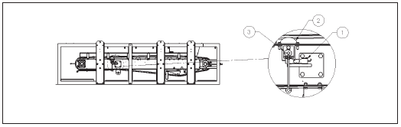 

**CAUTION:** Failure to remove tension from both load cells may result in damage to the cells, which would then have to be replaced.

1. Lock the gravity take-up roller by replacing the shipping bolt stop.

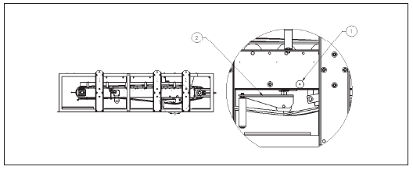

1. Shipping bolt stop
2. Gravity take-up.
3. Remove belt tension by loosening both take-up screws and pushing the tail pulley into the stringer frame.

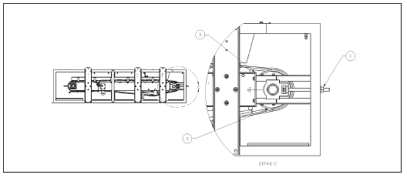

1. Take up screw.
2. Stringer Frame.
3. Tail Pulley.
4. Remove the take-up screw from the bearing on the access side (non-drive side) of the conveyor.

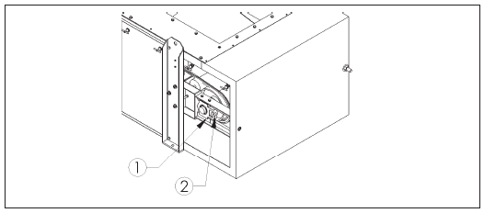

1. Take Up bearing.
2. Take up screw location.
3. Remove the take-up bracket bolts and remove the take-up brackets on the access side of the conveyor.

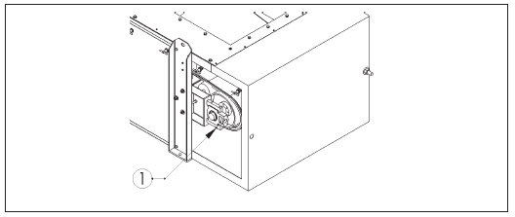

1. Take up
2. Remove the return idler(s) if present. slide.

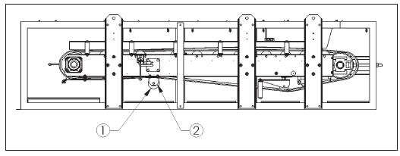

1. Return Idler.
2. Return Idler Bracket.
3. Remove the head pulley scraper (plow scraper) and, if present, tie up the return belt scraper to the stringer. (Scrapers are optional.)

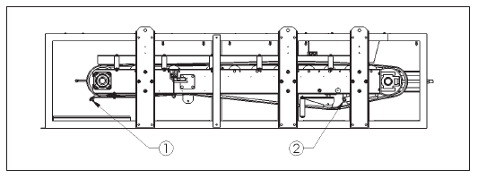

1. Head Pulley scrapper.
2. Return Belt Scrapper.
3. Remove the skirt board, guide roller, and overlap support on the access side. If a flanged belt is being replaced, both skirt boards must be removed.

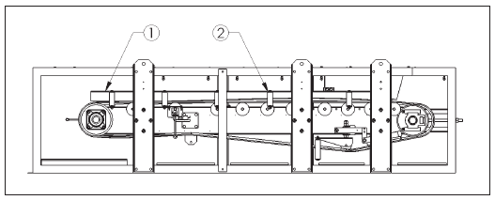

1. Skirt board.
2. Skirt Board bracket.
3. For machines supplied with flanged belts, remove the top cover (if supplied) and lift or block up the infeed to approximately four (4) inches.
4. Secure and brace the vertical legs on the drive side of the feeder. Provide overhead support of the frame angle mounted between the vertical support legs on the access side.

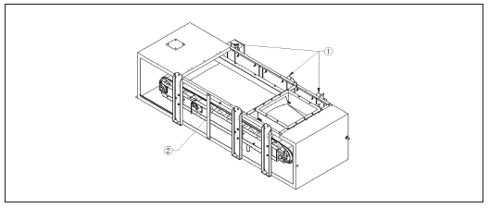

1. Vertical support leg on drive end.
2. Frame angle.
3. Remove the vertical support legs on the access side.

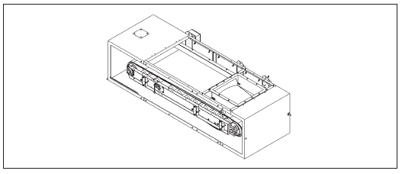

1. Remove and replace the feeder belt.

**NOTE:** The belt must be installed so that the metal triangle on the belt will pass over the belt sensor (if present). Position of metal triangle is marked on the belt and a magnet may be used to verify the metal triangle location.

When belt replacement is complete and the unit is re-assembled, the weigh feeder must be run to check belt tracking. In addition, re-calibration must be performed before putting the unit back into

operation.

1. Follow the reverse process for assembling the weigh feeder back to normal state.
2. Release the mechanical isolations if applied.
3. All unwanted material from the area to be removed before releasing the equipment electrical isolation.
4. Follow proper documented procedure for releasing the electrical isolations as per Vedanta approved isolation standards.
5. Ensure all the job is completed as planned and all safety guards have been placed and secured properly as per guidelines before releasing the equipment for operation.

# Activity No 2 : Belt Tensioning and Tracking.

**Material required**

Nil.

**Tools Required.**

1. General Toolbox.
2. Pipe Wrench

The SCHENCK Model DMO Weigh feeder is equipped with an automatic belt tracking assembly. If belt drift occurs under any conditions, an adjustment to the tail pulley will be necessary.

**Belt Tensioning and Tracking/Tail Pulley Adjustment Procedure:**

1. Locate the take-up screws to adjust belt tension.
2. By loosening or tightening the take-up screws, centre the shipping bolt in the belt tracking assembly within the sight hole(s) on each side of the feeder.
3. Adjust the tail pulley take-up by first tightening the take-up screw on the side the belt is tracking toward. Alternately loosen one side of the belt and tighten the other side to proper belt tracking.
4. After desired tension is achieved, start the weigh feeder and observe belt movement for 10-15 minutes.

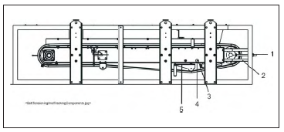

1. Take up screw.
2. Tail pulley take up.
3. Sight hole.
4. Shipping bolt.
5. Belt tracking assembly.

# Activity No 3 : Changing of gear box (weigh Feeder)

**Material Required.**

1. New/Overhauled gear box.
2. Hardware.

**Tools Required.**

1. General toolbox.
2. Chain Block – 1 T capacity.
3. Belt slings.
4. D shackles.
5. Crow bars.

**Procedure:**

1. Isolate the required belt feeder with proper isolation procedure as per the Vedanta isolation standard.
2. Ensure the belt is empty of coal / coke before taking isolation.
3. Seek work permit for replacement of gear box.
4. Disconnect the motor connection for removal of motor.
5. Remove the motor mounted on the gear box. (Refer activity 6 – Replacement of Motor)
6. Prepare suitable puller arrangement for removal of gear box from the drive drum.
7. Use hydraulic jack for dismounting of gear box from the drive drum.
8. Gear box to be properly secured with the suitable support for handling the removed gear box
9. New / Overhauled gear box to be positioned on shaft.
10. Prepare suitable pusher arrangement for mounting of gear box.
11. Use hydraulic jack arrangement for mounting gear box on shaft.
12. Ensure correct fitment of the gear box
13. Fix motor and secured properly with bolts. (Refer activity 4 – Replacement of Motor)
14. Inform Electrical team for motor connections.
15. All unwanted material from the area to be removed before releasing the equipment electrical isolation.
16. Follow proper documented procedure for releasing the electrical isolations as per Vedanta approved isolation standards.
17. Ensure all the job is completed as planned and all safety guards have been placed and secured properly as per guidelines before releasing the equipment for operation.

# Activity No 4 : Changing of motor (Weigh Feeder)

**Material Required.**

1. New/Overhauled motor.
2. Hardware.

**Tools Required.**

1. General toolbox.
2. Chain Block – 1 T capacity.
3. Belt slings.
4. D shackles.
5. Crow bars.

**Procedure:**

1. Isolate the required belt feeder with proper isolation procedure as per the Vedanta isolation standard.
2. Ensure the belt is empty of coal / coke before taking isolation.
3. Seek work permit for replacement of Motor.
4. Disconnect the motor connection for removal of motor.
5. Remove the bolts secured on motor and gear box flange.
6. Remove motor.
7. Install new motor and secure with fasteners.
8. Inform Electrical team for motor connections.
9. All unwanted material from the area to be removed before releasing the equipment electrical isolation.
10. Follow proper documented procedure for releasing the electrical isolations as per Vedanta approved isolation standards.
11. Ensure all the job is completed as planned and all safety guards have been placed and secured properly as per guidelines before releasing the equipment for operation.

# Activity No 5 : Changing of gear box (Belt Feeder)

**Material Required.**

1. New/Overhauled gear box.
2. Hardware.

**Tools Required.**

1. General toolbox.
2. Chain Block – 1 T capacity.
3. Belt slings.
4. D shackles.
5. Crow bars.

**Procedure:**

1. Isolate the required belt feeder with proper isolation procedure as per the Vedanta isolation standard.
2. Seek work permit for replacement of gear box.
3. Isolate drive by removing drive belts from the motor.
4. Decouple drive drum by removing coupling bolts and isolate the gear box.
5. Remove the foundation bolts of gear box.
6. Lift the gear box with proper lifting arrangement and shift out from the place.
7. Replace new / overhauled gear box duly fitted with coupling half and input pulley, similarly with the proper lifting arrangement.
8. Place the gear box on the base and ensure aligned properly.
9. Tighten the foundation bolts properly.
10. Provide coupling bolts on drive drum end coupling.
11. Align motor with the gear box and provide drive belt.
12. Tension the belts as per recommended tension.
13. All unwanted material from the area to be removed before releasing the equipment electrical isolation.
14. Follow proper documented procedure for releasing the electrical isolations as per Vedanta approved isolation standards.
15. Ensure all the job is completed as planned and all safety guards have been placed and secured properly as per guidelines before releasing the equipment for operation.

# Activity No 6 : Changing of motor (Belt Feeder)

**Material Required.**

1. New/Overhauled motor.
2. Hardware.

**Tools Required.**

1. General toolbox.
2. Chain Block – 1 T capacity.
3. Belt slings.
4. D shackles.
5. Crow bars.

**Procedure:**

1. Isolate the required belt feeder with proper isolation procedure as per the Vedanta isolation standard.
2. Seek work permit for replacement of motor
3. Disconnect the motor connection for removal of motor.
4. Remove motor foundation bolts and loosen the drive belts with gear box.
5. Lift the motor with proper lifting arrangement and shift from the place.
6. Replace new / overhauled motor duly fitted with pulley with proper lifting arrangement.
7. Place the motor on the base.
8. Mount the drive belts with gear box, align properly and tension the belts as per recommended tension.
9. Tighten the foundation bolts.
10. Inform Electrical team for motor connections.
11. All unwanted material from the area to be removed before releasing the equipment electrical isolation.
12. Follow proper documented procedure for releasing the electrical isolations as per Vedanta approved isolation standards.
13. Ensure all the job is completed as planned and all safety guards have been placed and secured properly as per guidelines before releasing the equipment for operation.

# Activity No 7 : Carrying roller/ bracket changing

**Material Required.**

1. Carrying Rollers
2. Carrying roller bracket.
3. Hardware.

**Tools Required.**

1. General toolbox.
2. Pipe for lifting belts.

**Procedure:**

1. Isolate the required belt feeder with proper isolation procedure as per the Vedanta isolation standard.
2. Ensure the belt is empty of coal / coke before taking isolation.
3. Remove side guards at the identified location of damaged roller.
4. Lift the belt manually by proper lifting arrangement
5. Remove the damaged / nonfunctional roller from the bracket,
6. Replace the new roller and ensure the same is properly fitted inside the bracket.
7. Fix the guards back in place and secured properly by hardware.
8. Remove the damaged bracket by removing the mounting bolts and taking the bracket out manually.
9. Replace the new bracket properly on frame and secured by hardware.
10. Shift the removed roller and bracket to scrap yard for proper disposal as per Vedanta guidelines of material disposal.
11. All unwanted material from the area to be removed before releasing the equipment electrical isolation.
12. Follow proper documented procedure for releasing the electrical isolations as per Vedanta approved isolation standards.
13. Ensure all the job is completed as planned and all safety guards have been placed and secured properly as per guidelines before releasing the equipment for operation.

# Activity No 8 : Return roller/ bracket changing

**Material Required.**

1. Return Rollers
2. Return roller bracket.
3. Hardware.

**Tools Required.**

1. General toolbox.
2. Pipe for lifting belts.

**Procedure:**

1. Isolate the required belt feeder with proper isolation procedure as per the Vedanta isolation standard.
2. Ensure the belt is empty of coal / coke before taking isolation.
3. Remove side guards at the identified location of damaged roller.
4. Lift the belt manually by proper lifting arrangement
5. Remove the damaged / nonfunctional roller from the bracket,
6. Replace the new roller and ensure the same is properly fitted inside the bracket.
7. Fix the guards back in place and secured properly by hardware.
8. Remove the damaged bracket by removing the mounting bolts and taking the bracket out manually.
9. Replace the new bracket properly on frame and secured by hardware.
10. Shift the removed roller and bracket to scrap yard for proper disposal as per Vedanta guidelines of material disposal.
11. All unwanted material from the area to be removed before releasing the equipment electrical isolation.
12. Follow proper documented procedure for releasing the electrical isolations as per Vedanta approved isolation standards.
13. Ensure all the job is completed as planned and all safety guards have been placed and secured properly as per guidelines before releasing the equipment for operation.

# Activity No 9 : Replacement of Drive drum.

**Material Required.**

1. Drive drum assembly.
2. Hardware.

**Tools Required.**

1. General toolbox.
2. Chain blocks – 2 Nos.
3. Belt slings.
4. D shackles.
5. Crow bars.

**Procedure:**

1. Isolate the required belt feeder with proper isolation procedure as per the Vedanta isolation standard.
2. Ensure the belt is empty of coal / coke before taking isolation.
3. Seek work permit for replacement of drive drum.
4. Decouple drive drum by removing the drive coupling bolts.
5. Loosen the belt by loosening the screw take up.
6. Remove drum bearing block foundation bolts.
7. Lift the belt as required for releasing of drum from the belt loop.
8. Use chain blocks in combination to lift and shift the drive drum out from the position.
9. Replace new drum duly fitted with bearing block assemblies, coupling half similarly with use of chain block in combination to mount the drum in position.
10. Provide bearing block foundation bolts and tighten properly.
11. Lock the bearings to position the drum and lubricate them before closing the bearing housing.
12. Ensure alignment of drive drum with the gear box and provide coupling bolts.
13. Tighten the belt by tensioning the screw take up.
14. All unwanted material from the area to be removed before releasing the equipment electrical isolation.
15. Follow proper documented procedure for releasing the electrical isolations as per Vedanta approved isolation standards.
16. Run the belt on no load and track the belt and check the operation of belt for any belt sway.
17. Ensure all the job is completed as planned and all safety guards have been placed and secured properly as per guidelines before releasing the equipment for operation.

# Activity No 10 : Replacement of Tail drum.

**Material Required.**

1. Tail drum assembly.
2. Hardware.

**Tools Required.**

1. General toolbox.
2. Chain blocks – 2 Nos.
3. Belt slings.
4. D shackles.
5. Crow bars.

**Procedure:**

1. Isolate the required belt feeder with proper isolation procedure as per the Vedanta isolation standard.
2. Ensure the belt is empty of coal / coke before taking isolation.
3. Seek work permit for replacement of tail drum.
4. Loosen the belt by loosening the screw take up.
5. Remove drum bearing block foundation bolts.
6. Lift the belt as required for releasing of drum from the belt loop.
7. Use chain blocks in combination to lift and shift the tail drum out from the position.
8. Replace new drum duly fitted with bearing block assemblies, similarly with use of chain block in combination to mount the drum in position.
9. Provide bearing block foundation bolts and tighten properly.
10. Lock the bearings to position the drum and lubricate them before closing the bearing housing.
11. Tighten the belt by tensioning the screw take up.
12. All unwanted material from the area to be removed before releasing the equipment electrical isolation.
13. Follow proper documented procedure for releasing the electrical isolations as per Vedanta approved isolation standards.
14. Run the belt on no load and track the belt and check the operation of belt for any belt sway.
15. Ensure all the job is completed as planned and all safety guards have been placed and secured properly as per guidelines before releasing the equipment for operation.

# Activity No 11 : Replacement of snub drum.

**Material Required.**

1. Snub drum assembly.
2. Hardware.

**Tools Required.**

1. General toolbox.
2. Chain blocks – 2 Nos.
3. Belt slings.
4. D shackles.
5. Crow bars.

**Procedure:**

1. Isolate the required belt feeder with proper isolation procedure as per the Vedanta isolation standard.
2. Ensure the belt is empty of coal / coke before taking isolation.
3. Seek work permit for replacement of snub drum.
4. Loosen the belt by loosening the screw take up.
5. Remove drum bearing block foundation bolts.
6. Lift the belt as required for releasing of drum from the belt loop.
7. Use chain blocks in combination to lift and shift the snub drum out from the position.
8. Replace new drum duly fitted with bearing block assemblies, similarly with use of chain block in combination to mount the drum in position.
9. Provide bearing block foundation bolts and tighten properly.
10. Lock the bearings to position the drum and lubricate them before closing the bearing housing.
11. Tighten the belt by tensioning the screw take up.
12. All unwanted material from the area to be removed before releasing the equipment electrical isolation.
13. Follow proper documented procedure for releasing the electrical isolations as per Vedanta approved isolation standards.
14. Run the belt on no load and track the belt and check the operation of belt for any belt sway.
15. Ensure all the job is completed as planned and all safety guards have been placed and secured properly as per guidelines before releasing the equipment for operation.

# Activity No 12 : Replacement of Screw take Up.

**Material Required.**

1. Tail drum assembly.
2. Hardware.

**Tools Required.**

1. General toolbox.
2. Chain blocks – 2 Nos.
3. Belt slings.
4. D shackles.
5. Crow bars.

**Procedure:**

1. Isolate the required belt feeder with proper isolation procedure as per the Vedanta isolation standard.
2. Ensure the belt is empty of coal / coke before taking isolation.
3. Seek work permit for replacement of gear box.
4. Remove the tail drum bearing block foundation bolt on the side of replaceable screw take up.
5. Remove the mounting bolts of screw take up and remove the screw take up assembly.
6. Replace the screw take up and secure the mounting bolts.
7. Place the bearing block on the screw take up base and provide bearing block foundation bolts.
8. Tighten the belt by tensioning the screw take up.
9. All unwanted material from the area to be removed before releasing the equipment electrical isolation.
10. Follow proper documented procedure for releasing the electrical isolations as per Vedanta approved isolation standards.
11. Run the belt on no load and track the belt and check the operation of belt for any belt sway.
12. Ensure all the job is completed as planned and all safety guards have been placed and secured properly as per guidelines before releasing the equipment for operation.

# Activity No 13 : Preventive Maintenance.

Preventive Maintenance of Belt feeders and Weigh feeders are cover under

1. CLTI. (Cleaning, Lubrication, Tightening, Inspection)
2. Monthly Preventive maintenance.
3. Quarterly Preventive Maintenance.
4. Half Yearly Preventive Maintenance.
5. Yearly Maintenance.

CLTI is basically is routine run check inspection and any identified abnormality is documented and updated in SAP in MR Notification. On opportunity the same is resolved and the abnormality is closed.

**Procedure for Preventive maintenance**

1. Check the preventive maintenance schedule in SAP.
2. Take system generated print of generated PM and hand it over to maintenance crew for execution.
3. Isolate the required Weigh Feeder / belt feeder with proper isolation procedure as per the Vedanta isolation standard.
4. Carry out all tasks mentioned in the checklist as per guidelines and update the job completed and actual conditions with the time taken for completion of the job.
5. Ensure all the jobs are completed and in case of any abnormality or pending jobs in the list, a separate notification has to be raised in SAP for ensuring the compliance.
6. All unwanted material from the area to be removed before releasing the equipment electrical isolation.
7. Follow proper documented procedure for releasing the electrical isolations as per Vedanta approved isolation standards.
8. Run the belt on no load and track the belt and check the operation of belt for any belt sway.
9. Ensure all the job is completed as planned and all safety guards have been placed and secured properly as per guidelines before releasing the equipment for operation.
10. After completion of PM activity, the generated order needs to be closed within 24 hrs of the execution.
    1. **RECORDS:**

|  |  |  |  |  |  |
| --- | --- | --- | --- | --- | --- |
| **Sr. No.** | **Record No.** | **Record Title** | **Maintained by** | **Soft/Hard form** | **Retention Time** |
| 1. |  | CLTI | Area in Charge | Hard | 1 Yr. |
| 2. |  | PM Checklist | Area in Charge | Hard | 1 Yr. |
| 3. |  | Notification Data | Area in charge | Soft |  |
| 4. |  | Hazard Identification | IMS | Soft | 1 Yr. |
| 5. |  | Risk Assessment | IMS | Soft | 1 Yr. |

|  |  |  |  |
| --- | --- | --- | --- |
| **Date** | **Manual Section Ref. & Para** | **Brief details of Revision** | **New Rev.** |
| 13-08-2022 | Header | Company logo & Document no. | 07 |
|  |  |  |  |
|  |  |  |  |

|  |  |  |
| --- | --- | --- |
| **Prepared By:**  Head Mechanical Maintenance, Battery 1- MCD | **Reviewed & Issued By:**  Management Representative | **Approved By:**  Head Mechanical Maintenance MCD |
| **Signature:** | **Signature:** | **Signature:** |
| **Review Date: 13.08.2022** | **Review Date: 13.08.2022** | **Review Date: 13.08.2022** |